BACHELOR OF SCIENCE IN NURSING:
COMMUNITY HEALTH NURSING
COURSE MODULE | COURSE TOPIC | WEEK
I | 2 | 2
THE HEALTH CARE DELIVERY SYSTEM
Read course and unit
- Read course and unit objectives
- Read study guide prior to class attendance
- Read required learning resources; refer to unit
terminologies for jargons
- Proactively participate in classroom/online discussions
- Participate in weekly discussion board (Canvas)
- Answer and submit course unit tasks

- Module, Reference Books, Laptop, Internet, Headset
- Books: Nursing Care of the Community “A comprehensive text on community and public health nursing in the Philippines” 1st Edition Zenaida Famorca
Cognitive
- Discuss appropriate community health nursing concepts and actions holistically and comprehensively.
- Differentiate Community Health Nursing, Public Health Nursing and Community-based Nursing.
- Recall the different nursing interventions.

Affective
- Integrate relevant principles of social, physical, natural and health sciences and humanities in a given health and nursing situation in the community.
- Value the importance of Nurses in the community

Psychomotor
- Manage resources efficiently and effectively.
- Model professional behavior as a community health nurse

THE HEALTH CARE DELIVERY SYSTEM
A. WORLD HEALTH ORGANIZATION
WHO is the directing and coordinating authority for health within the United Nations system. It is responsible for providing leadership on global health matters, shaping the health research agenda, setting norms and standards, articulating evidence-based policy options, providing technical support to countries and monitoring and assessing health trends.
Who We Are? | Established 7 April 1948. – a date we now celebrate every year as World Health Day. Headquarters in Geneva, Switzerland
What We Do? | WHO works worldwide to promote health, keep the world safe, and serve the vulnerable.  Our goal is to ensure that a billion more people have universal health coverage, to protect a billion more people from health emergencies, and provide a further billion people with better health and well-being.
Where We Work? | We support Member States as they coordinate the efforts of multiple sectors of the government and partners – including bi- and multilaterals, funds and foundations, civil society organizations and private sector – to attain their health objectives and support their national health policies and strategies.
How We Are Governed? | The World Health Assembly is attended by delegations from all Member States, and determines the policies of the Organization.
Who We Work With? | Our core function is to direct and coordinate international health work through collaboration.  WHO partners with countries, the United Nations system, international organizations, civil society, foundations, academia, and research institutions.

- Millennium Development Goal

On September 6 to 8, 2000, world leaders on UN General Assembly participate in Millennium Summit. The result of the summit was a resolution entitled United Nations Millennium Declaration. In this declaration, the world leaders recognized their collective responsibility to uphold the principles of human dignity, equality and equity at the global level.
The declaration expressed the commitment of the 191 member states, including the Philippines, to reduce extreme poverty and achieve seven other targets - now called the Millennium Development Goals (MDG’s) by the year 2015.

The following are the eight MDG’s and the targets corresponding to health-related MDG’s 4,5, and 6:

- Eradicate extreme poverty and hunger.
- Achieve universal primary education.
- Promote gender equality and empower women.
- Reduce child mortality. Target: reduce by 2/3, between 1990 and 2015, the under-five mortality rate.
- Improve maternal health. Target:
- Reduce by three quarters the maternal mortality ratio
- Achieve universal access to reproductive health
- Combat HIV/AIDS, malaria and other diseases. Targets:
- Have halted by 2015 and begun to reverse the spread of HIV/AIDS
- Achieve by 2010, universal access to treatment for all those who need it
- Have halted by 2015, and begun to reverse the incidence of malaria and other major diseases.
- Ensure environmental sustainability
- Develop a global partnership for development

- Sustainable Development Goal
Goal 1 : End poverty and all its forms everywhere
Goal 2 : End hunger, achieve food security and improved nutrition and promote sustainable agriculture
Goal 3 : Ensure healthy lives and promote well-being for all at all ages
Goal 4 : Ensure inclusive and equitable quality education and promote lifelong learning opportunities for all
Goal 5 : Achieve gender equality and empower all women and girls
Goal 6 : Ensure availability and sustainable management of water and sanitation for all
Goal 7 : Ensure access to affordable, reliable, sustainable and modern energy for all
Goal 8 : Promote sustained, inclusive and sustainable economic growth, full and productive employment and decent work for all
Goal 9 : Build resilient infrastructure, promote inclusive and sustainable industrialization and foster innovation
Goal 10 : Reduce inequality within and among countries
Goal 11 : Make cities and human settlements inclusive, safe, resilient and sustainable
Goal 12 : Ensure sustainable consumption and production patterns
Goal 13 : Take urgent action to combat climate change and its impacts
Goal 14 : Conserve and sustainably use the oceans, seas and marine resources for sustainable development
Goal 15 : Protect, restore and promote sustainable use of terrestrial ecosystems, sustainably manage forests, combat desertification, and halt and reverse land degradation and halt biodiversity loss
Goal 16 : Promote peaceful and inclusive societies for sustainable development, provide access to justice for all and build effective, accountable and inclusive institutions at all levels
Goal 17 : Strengthen the means of implementation and revitalize the global partnership for sustainable development

B. PHILIPPINE DEPARTMENT OF HEALTH

1. Mission-Vision
The Department of Health (DOH) holds the over-all technical authority on health as it is a national health policy-maker and regulatory institution.

Mission | To lead the country in the development of a productive, resilient, equitable and people-centered health system
Vision | Filipinos are among the healthiest people in Southeast Asia by 2022, and Asia by 2040
Roles in the Health Sector | (1) leadership in health;  (2) enabler and capacity builder; and  (3) administrator of specific services
Mandate | To develop national plans, technical standards, and guidelines on health

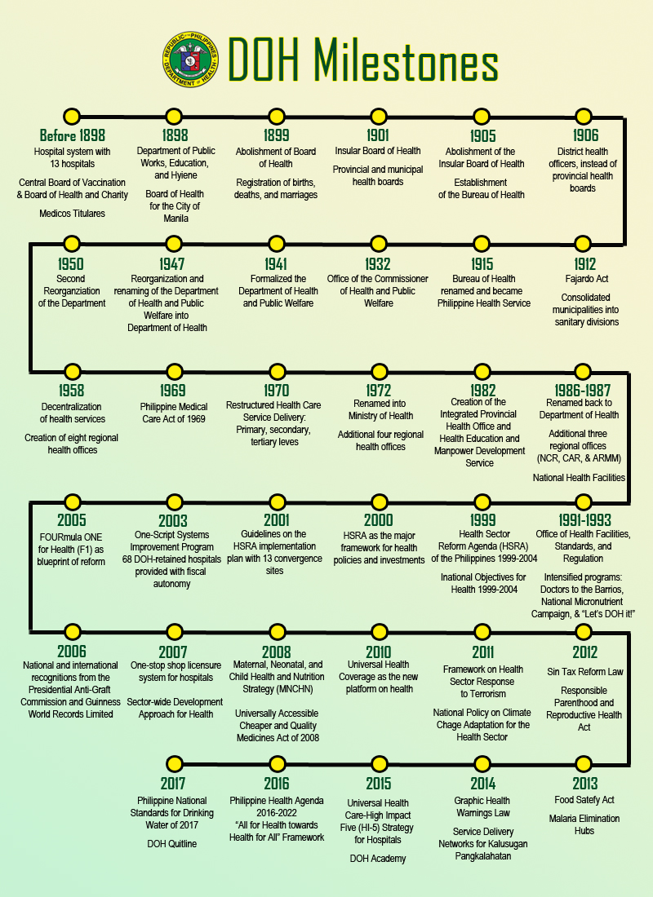
2. Historical Background

3. Local Health System and Devolution of Health Services

The 1987 Philippine Constitution mandated the Congress to “enact a local government code which shall provide for a more responsive and accountable local government structure instituted through a system of decentralization with effective mechanisms of recall, initiative and referendum, allocate among the different local government units their powers, responsibilities, and resources, and provide for the qualifications, election, appointment and removal, term, salaries, powers and functions and duties of local officials, and all other matters relating to the organization and operation of the local units (Section 3, Article X).” In response to this Constitutional directive, the Congress legislated the Republic Act No. 7160, otherwise known as the Local Government Code of 1991 (hereafter Code), which was signed into law on October 10, 1991 and took effect on January 1, 1992.

The enactment of the Code has changed the way basic government health services are delivered at the local level. From a highly centralized system of health service delivery with the Department of Health (DOH) as the sole provider, the Code mandated the devolution1 to local government units (LGUs)2 of many of the functions previously discharged by DOH. Health devolution or decentralization of health services was initially geared towards efficiency and effectiveness of health service delivery by reallocating decision-making capability and resources to LGUs (Grundy et al. 2003; Galvez-Tan et al. 2010).

Decentralization is a core element of the implementation of the Primary Health Care (PHC), which is a strategy adopted by DOH in the late 1970s (DOH 1997; Perez 1998a; Grundy et al. 2003; DOH-BLHD 2013; NCPAG-CPED 2014) in compliance with the Declaration of Alma Ata on PHC3 to ensure that essential health care4 is “made universally accessible to individuals and families in the community through their full participation and at a cost that the community and country can afford … (Alma-Ata Declaration 1978).”

The Philippine’s local health systems were established on PHC principles (Perez 1998a), which is basically “Health in the Hands of the People,” thus signifying empowerment of the people in managing their health and health service delivery (Galvez-Tan 2013). The Code ushered in participatory local governance and placed health care in the hands of the people (DOHLGAMS 1993). In this sense, health devolution has not empowered LGUs alone but also the people by allowing them to participate in policy and decision-making that concerns delivery and quality of health care (DOH-BLHD nd).

As a result of health devolution, LGUs have taken on the great responsibility in the delivery of basic services and in the operation of facilities in areas that include primary health care and hospital care/services. On the other hand, the DOH5 has become the leader, enabler, standard setter (or regulator-enforcer of standards/ regulation) for health services planning and service provision and delivery, policy maker, health advocate, resource center, mobilizer, and technical adviser as well as administrator of regional and special hospitals (DOH-BLHD nd; Mercado et al. 1996; Romualdez et al. 2011; DOH-BLHD 2013). In other words, it has assumed the role of the “national technical authority on health,” which implies that it is expected to “ensure the highest achievable standards of quality health care, health promotion and health protection” that LGUs, non-government organizations (NGOs), private organizations (POs), and civil society should uphold (DOH-BLHD 2013, p.7).

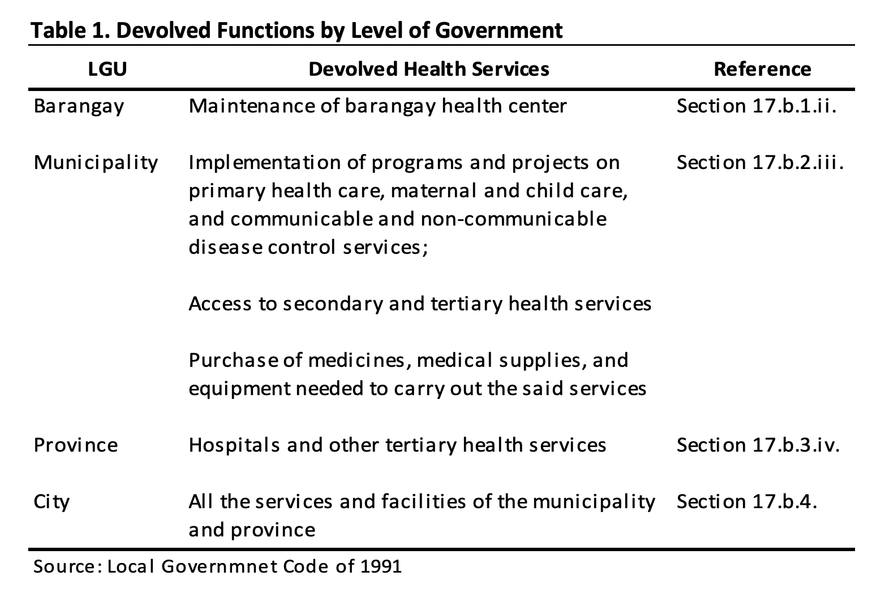

Based on the Department of Health (DOH) Rules and Regulations Implementing the Local Government Code of 1991 (DOH Task Force on Decentralization 1992), primary health services are otherwise known as basic health services, which are delivered at health centers or rural health units (RHUs) and barangay6 health stations (BHS). These services include health education; control of locally endemic diseases such as malaria, dengue, schistosomiasis; expanded program of immunization (against tuberculosis, polio, measles, diphtheria, whooping cough, and tetanus); maternal and child health and family planning; environmental sanitation and provision of safe water supply; nutrition; treatment of common diseases; and supply of essential drugs (DOH-LGAMS 1993).

On the one hand, secondary health services are medical services that are accessible in some rural health units, infirmaries, district hospitals, and out-patient departments of provincial hospitals. On the other hand, tertiary health services include medical and surgical diagnostics, treatment, and rehabilitative care that are usually provided by medical specialists in a hospital setting (DOH Task Force on Decentralization 1992). Not all DOH powers, functions, and responsibilities have been devolved. The DOH takes on the residual powers and functions that include oversight or general supervision of the health sector, monitoring and evaluation functions, formulation of standards and regulation, and provision of technical and other forms of assistance (DOH-LGAMS 1993).

4. Classification of Health Care Facilities
The DOH issued administrative order 2012-0012 (Rules and Regulations Governing the new Classification of Hospitals and Other Health Facilities in the Philippines) that provides for a new classification scheme of health facilities.

Hospitals  General  - Level 1  - Level 2  - Level 3 (teaching/ training)  Specialty | Other Health Facilities  A. Primary Care Facility  B. Custodial facility  C. Diagnostic/ Therapeutic facility  D. Specialized outpatient facility

DOH administrative Order 2012-0012 classifies other health facilities as follows:

Category A. Primary Health Care Facility – a first contact health care facility that offers basic service including emergency services and provision for normal deliveries.
- Without in-patient beds like health centers, out-patient clinics, and dental clinics.
- With in-patient beds – a short-stay facility where the patient spends on the average of one to two days before discharge.
Ex: Infirmaries and birthing (Lying-in) facilities.

Category B. Custodial Care Facility – a health facility that provides long-term care, including basic services like food and shelter, to patients with chronic conditions requiring ongoing health and nursing care due to impairment and a reduced degree of independence in activities of daily living, and patients in need of rehabilitation.
Ex: Custodial health care facilities, substance/drug abuse treatment and rehabilitation centers, sanitaria, leprosaria, and nursing homes.

Category C. Diagnostic/Therapeutic Facility - a facility for the examination of the human body, specimens from the human body for the diagnosis, sometimes treatment of disease or water for drinking analysis. The test covers the preanalytical, analytical and post analytical phases of examination.

Category D. Specialized outpatient facility – a facility that performs highly specialized procedures on an outpatient basis.
Ex: Dialysis clinic, ambulatory surgical clinic, cancer chemotherapeutic center/clinic, cancer radiation facility, and physical medicine and rehabilitation center/clinic.

The Rural Health Unit

The RHU, commonly known as health center, is a primary level health facility in the municipality. The focus of RHU is preventive and promotive health services and the supervision of BHSs under its jurisdiction. The recommended ratio of RHU to catchment population is 1 RHU: 20,000 populations.

The BHS is the first contact health care facility that offers basic services at the barangay level. It is a satellite station of the RHU. It is manned by Volunteer Barangay Health Workers (BHW’s) under the supervision of Rural Health Midwife (RHM).

The Rural Health Unit Personnel

The Municipal Health Officer (MHO) or Rural Health Physician heads the health services at the municipal level and carries out the following roles and functions:
1. Administrator of the RHU
2. Prepares the municipal health plan and budget
3. Monitors the implementation of basic health services
4. Management of the RHU staff
5. Community physician
6. Conducts epidemiological studies
7. Formulates health education campaigns on disease prevention
8. Prepares and implements control measures or rehabilitation plan
9. Medico-legal officer f the municipality.

The revised implementing rules and regulations (IRRSs) of R.A. 7305 or the Magna Carta of Public Health Workers stipulate that there be one rural health physician to a population of 20,000.

5. Philippine Health Agenda 2016-2022

President Rodrigo Duterte has recently released the Philippine Health Agenda 2016-2022, which strengthens the Duterte Health Agenda, “All for Health towards Health for All”. This health system, through the Department of Health, aspires financial protection, better health outcomes and responsiveness for all Filipinos. In order to attain health-related sustainable development goals, the A.C.H.I.E.V.E. strategy is followed: A- Advance quality, health promotion and primary care, C- Cover all Filipinos against health-related financial risk, H- Harness the power of strategic HRH development, I- Invest in eHealth and data for decision-making, E- Enforce standards, accountability and transparency, V- Value all clients and patients, especially the poor, marginalized, and vulnerable, E- Elicit multi-sectoral and multi-stakeholder support for health.

Submit: Word File
Points: 60pts
Requirements: Both questions must be answered in a table format.

Question:

  - (40pts) In line with the WHO Health Protocol during the COVID-19 Pandemic, what are the public health interventions done in your community? What are the advantages and disadvantages of these interventions to:
  - Public Health Workers?
  - Individuals?
  - Families?
  - Community?

2. (20pts) Using Leavell and Clark’s Three Levels of Prevention. How does a nurse use these preventions concerning malnutrition among young children in a community?

Famorca, Z., Nies, M., & McEwen, M., (2013). Nursing Care of the Community. ELSEVIER MOSBY.

Famorca, Z., Nies, M., & McEwen, M., (2013). Nursing Care of the Community. ELSEVIER MOSBY.

