BACHELOR OF SCIENCE IN NURSING:
COMMUNITY HEALTH NURSING
COURSE MODULE | COURSE TOPIC | WEEK
2 | 2 | 8
DOH PROGRAMS
Illustrated Management of Childhood Illness
- Read course and unit Rea
- Read study guide prior to class attendance
- Read course unit and objectives
- Read required learning resources; refer to unit
terminologies for jargons
- Proactively participate in classroom/online discussions
- Participate in weekly discussion board (Canvas)
- Answer and submit course unit tasks
- Module, Reference Books, Laptop, Internet, Headset
- Books; Integrated Management of Childhood Illness Resource Manual and Workbook (C&E Publishing)
Cognitive
- Discuss appropriate community health nursing concepts and actions holistically and comprehensively.
- Compare the task between WHO and DOH.
- Evaluate the different values and statistical data provided by DOH and WHO.
Affective
- Model professional behavior as community health nurse
- Maintain a harmonious and collegial relationship among members of the health team for effective, efficient and safe client care.
- Listen to your professor as they teach the lesson.
- Value the importance of these organizations

Psychomotor
- Manage resources efficiently and effectively.

INTRODUCTION

The WHO/UNICEF guidelines for Integrated Management of Childhood Illness (IMCI) offer simple and effective methods to prevent and manage the leading causes of serious illness and mortality in young children. The clinical guidelines promote evidence-based assessment and treatment, using a syndromic approach that supports the rational, effective and affordable use of drugs. The guidelines include methods for checking a child’s immunization and nutrition status; teaching parents how to give treatments at home; assessing a child’s feeding and counselling to solve feeding problems; and advising parents about when to return to a health facility. The approach is designed for use in outpatient clinical settings with limited diagnostic tools, limited medications and limited opportunities to practice complicated clinical procedures.

In each country, the IMCI clinical guidelines are adapted:
- To cover the most serious childhood illnesses typically seen at first-level health facilities
- To make the guidelines consistent with national treatment guidelines and other policies
- To make the guidelines feasible to implement through the health system and by families caring for their children at home.

Foreword

Since the 1970s, the estimated annual number of deaths among children less than 5 years old has decreased by almost a third. This reduction, however, has been very uneven. And in some countries rates of childhood mortality are increasing. In 1998, more than 50 countries still had childhood mortality rates of over 100 per 1000 live births.1 Altogether more than 10 million children die each year in developing countries before they reach their fifth birthday. Seven in ten of these deaths are due to acute respiratory infections (mostly pneumonia), diarrhoea, measles, malaria, or malnutrition—and often to a combination of these conditions (figure 1).

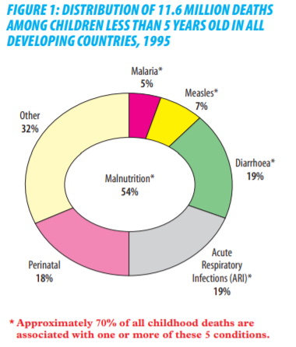

INTERGRATED MANAGEMENT OF CHILDHOOD ILLNESS

- A strategy for reducing mortality and morbidity associated with major causes of childhood illness
- A joint WHO/UNICEF initiative since 1992
- Currently focused on first level health facilities
- Comes as a generic guidelines for management which been adapted to each country.

Pneumonia, diarrhea, dengue hemorrhagic fever, malaria, measles and malnutrition cause more than 70% of the deaths in children under 5 years of age. All these are preventable diseases in which when managed and treated early could have prevented these deaths. There are feasible and effective ways that health worker in health centers can care for children with these illnesses and prevent most of these deaths. WHO and UNICEF used updated technical findings to describe management of these illnesses in a set of integrated guidelines for each illness. They then developed this protocol to teach the integrated case management process to health worker who see sick children and know which problems are most important to treat. Therefore, effective case management needs to consider all of a child’s symptoms.

Objectives of IMCI

- To reduce significantly global morbidity and mortality associated with the major causes of illnesses in children
- To contribute to healthy growth and development of children.

CASE MANAGAMENT PROCESS

The CASE MANAGEMENT PROCESS is used to assess and classify two age groups:

- age 1 week up to 2 months
- age 2 months up to 5 years
And how to use the process shown on the chart will help us to identify signs of serious disease such pneumonia, diarrhea, malaria, measles, DHF, meningitis, malnutrition and anemia.

The Case Management Process

- The charts describes the following steps;
1. Assess the child or young infant
2. Classify the illness
3. Identify the treatment
4. Treat the child
5. Counsel the mother
6. Give follow up care

The Classification Table
- The classification tables on the assess and classify have 3 Rows.
- Color of the row helps to identify rapidly whether the child has a serious disease requiring urgent attention.
- Each row is colored either –
    - PINK – means the child has a severe classification and needs urgent attention and referral or admission for inpatient care.
    - YELLOW – means the child needs a spec eds a specific medical treatment such as an appropriate antibiotic, an oral anti-malarial or other treat other treatment; also teaches the mother how to give oral drugs l drugs or to treat local infections at home. The health worker teaches the mother how to care for her child at home and when she should return.
    - GREEN – not given a specific medical treatment such as antibiotics or treatments. The health worker h worker teaches the mother how her how to care for her child at home.
- Always start at the top of the classification table. If the child has signs from more than 1 row always select the more serious classification.

Why not use the process for children age 5 years or more?

- The case he case management process is designed for children < 5yrs of age, although. Much of the advise on treatment of pneumonia, diarrhea, malaria, measles and malnutrition, is also applicable to older children, the ASSESSMENT AND CLASSIF D CLASSIFICATION of older children would differ. For example, the cut off rate for determining fast breathing would be d would be different because normal breathing rates are slower in older chi older children. Chest indrawing is no indrawing is not a reliable sign of severe pneumonia as children get older and the bones of the chest become more firm.
- In addition, certain treatment recommendations or advice to mothers on hers on feeding would differ for >5yrs r >5yrs old. The drug dosing he drug dosing tables only apply to chi ply to children up to 5yrs old. The feeding advice for older children may differ and they may have ay have different feeding problems.
- Because of differences in the clinical signs of older and younger children who have th ldren who have these illnesses, the assessment and classification process using these clinical signs is not recommended for older children.

Why not use this process for young infants age < 1 week old?

- The process on young infant chart is designed for infants age 1 week up to 2 months. It greatly differs from older infants and young children. In the first week of life, newborn infants are often sick from conditions related to labor and delivery. Their conditions require special treatment.

Identification and provision of treatment

- Curative component adapted to address the most common life-threatening conditions in each country
- Rehydration (diarrhea, DHF)
- Antibiotics (pneumonia, “severe disease”)
- Antimalarial treatment
- Vitamin A (measles, severe malnutrition)

Promotive and preventive elements
- Reducing missed opportunities for immunization (vaccination given if needed)
- Breastfeeding and other nutritional counseling
- Vitamin A and iron supplementation
- Treatment of helminth infections

THE INTEGRATED CASE MANAGEMENT PROCESS

Overall Case Management Process

Outpatient
- Assessment
- Classification and identification of treatment
- Referral, treatment or counseling of the child’s caretaker (depending on the classification identified)
- Follow-up care

Referral Health Facility
- Emergency triage assessment and treatment
- Diagnosis, treatment and monitoring of patient’s progress

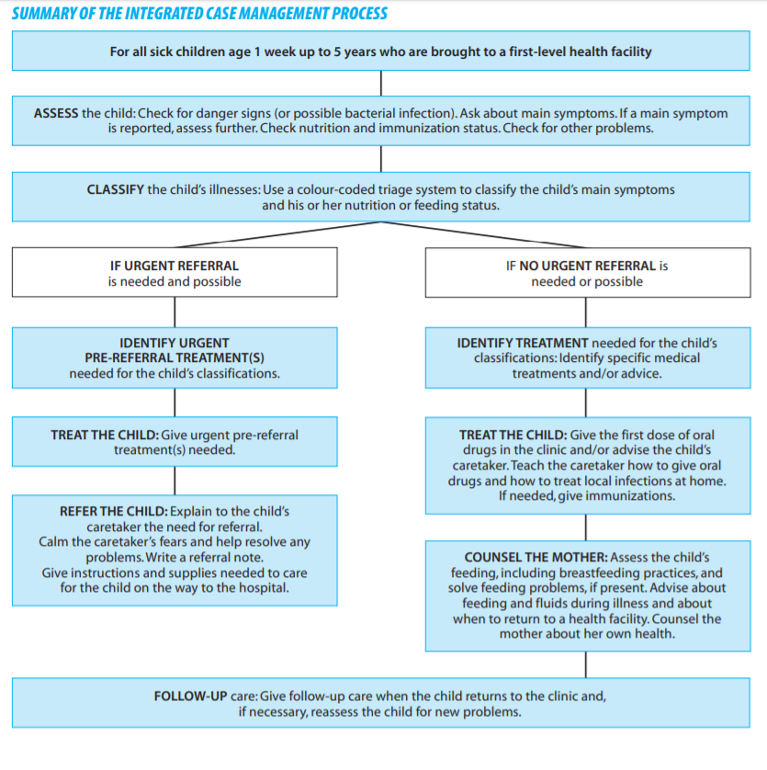

Selecting the appropriate case management charts

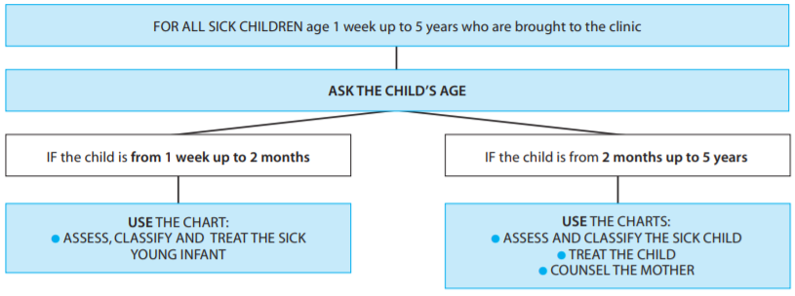

The sick child age 2 months to 5 years (Assess and Classify)

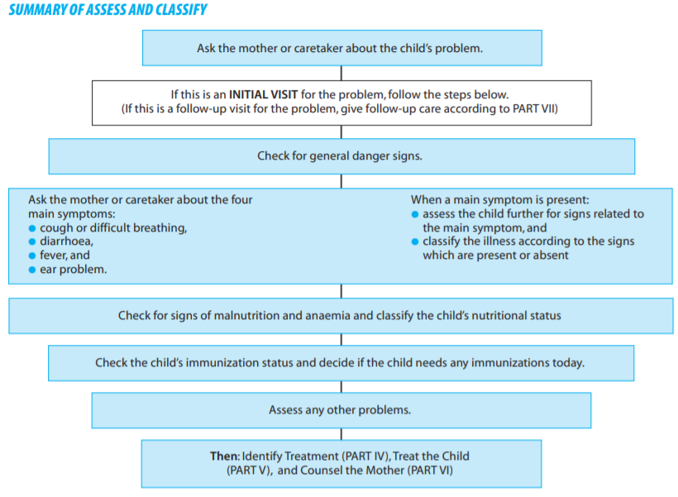
When a child is brought to the clinic

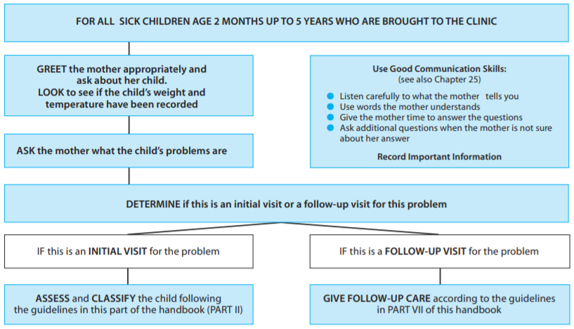

General Danger Signs

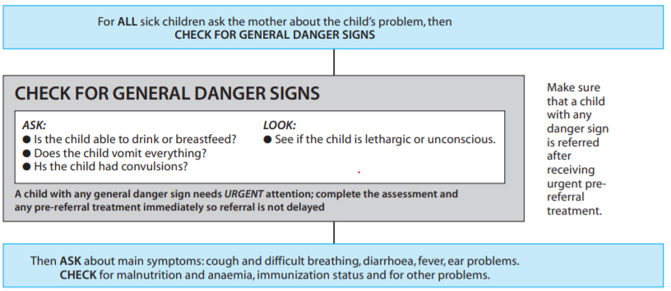

Cough or difficult breathing

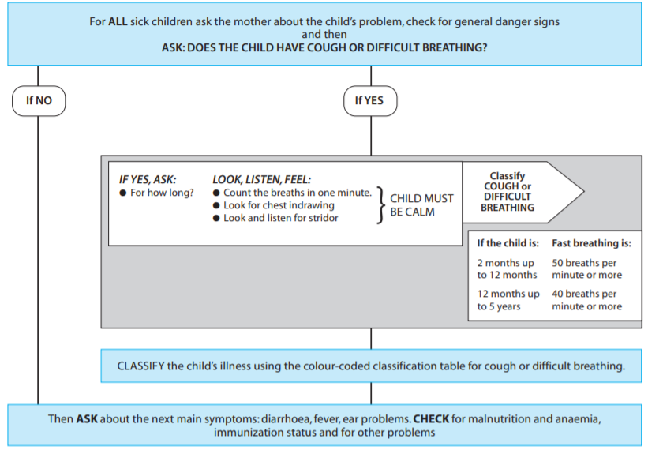

CLASSIFICATION TABLE FOR COUGH OR DIFFICULT BREATHING

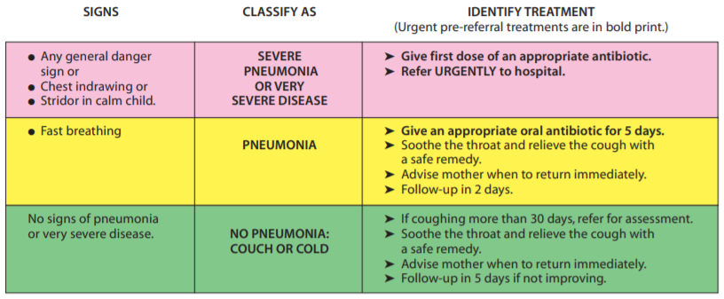

ILLNESSES

Diarrhea

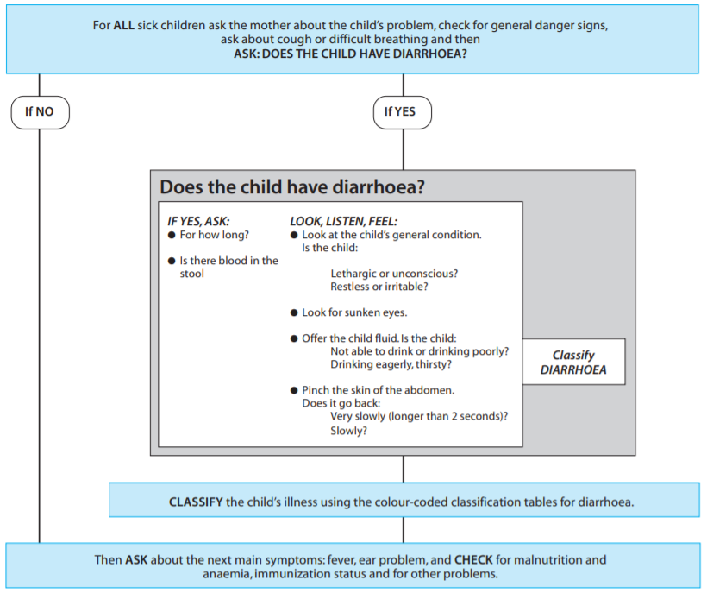

CLASSIFICATION FOR TABLE WITH DEHYDRATION

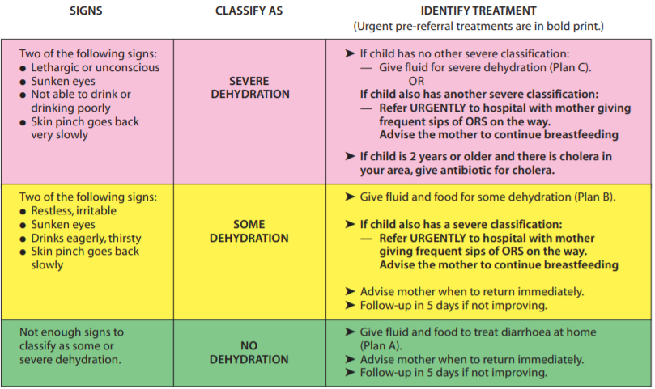

CLASSIFICATION TABLE FOR PERSISTENT DIARRHEA

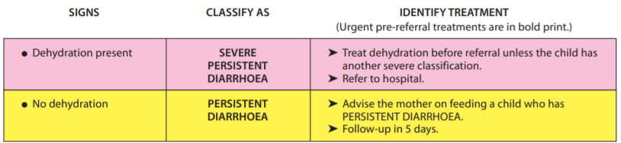

CLASSIFICATION TABLE FOR DYSENTERY
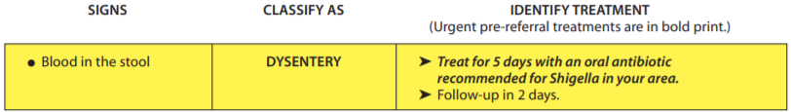

FEVER

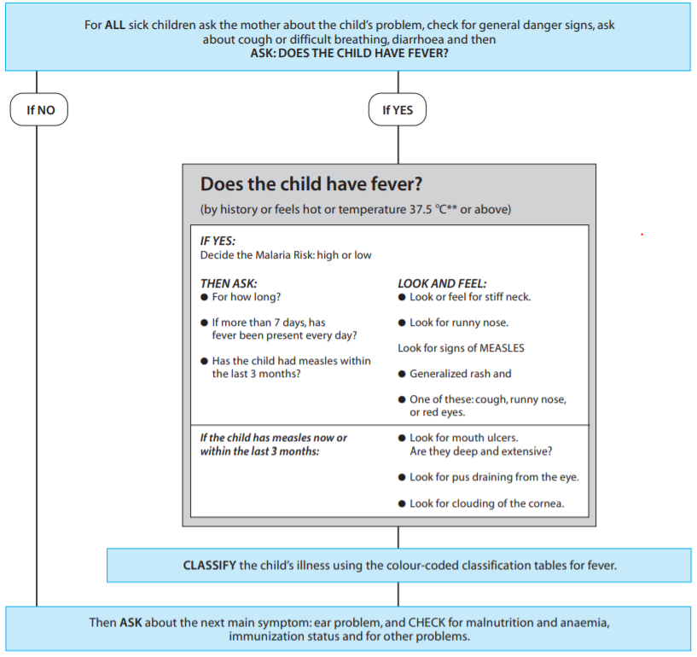

CLASSIFICATION TABLE FOR NO MALARIA RISK AND NO TRAVEL TO A MALARIA RISK AREA

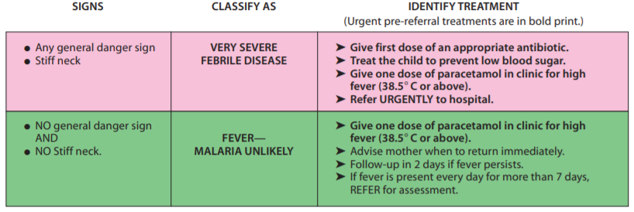

CLASSIFICATION TABLE FOR MEASLES (IF MEASLES NOW OR WITHIN THE LAST 3 MONTHS)

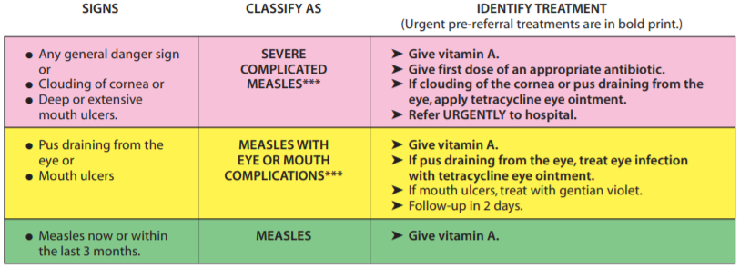

FEVER WITH RASHES

Ear Problem

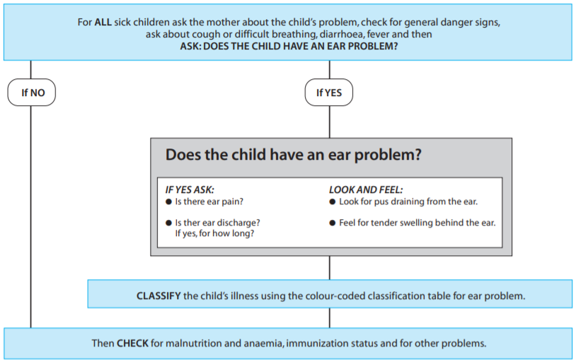

Classification table for ear problem

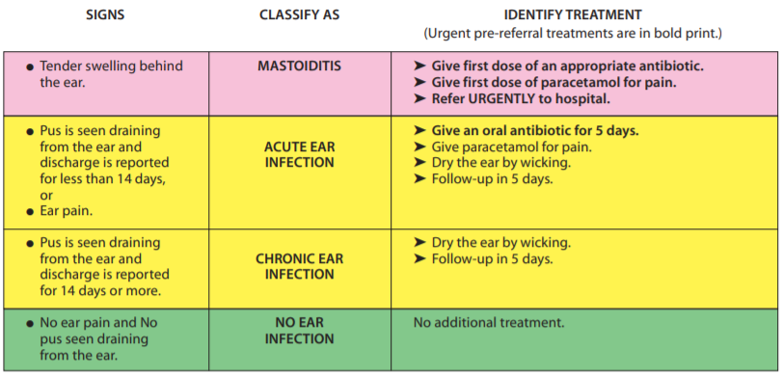

Malnutrition and Anemia

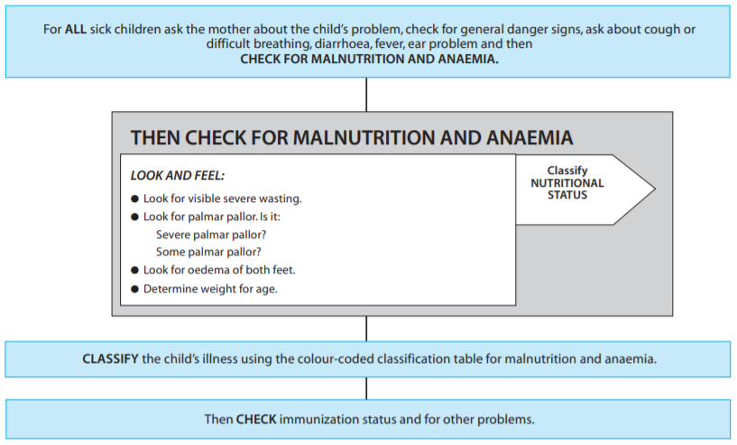

CHILD WITH ANEMIA AND MALNUTRITION

Classification table for malnutrition and anemia
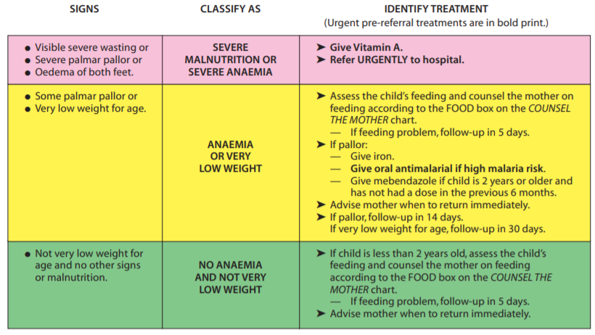

Immunization Status

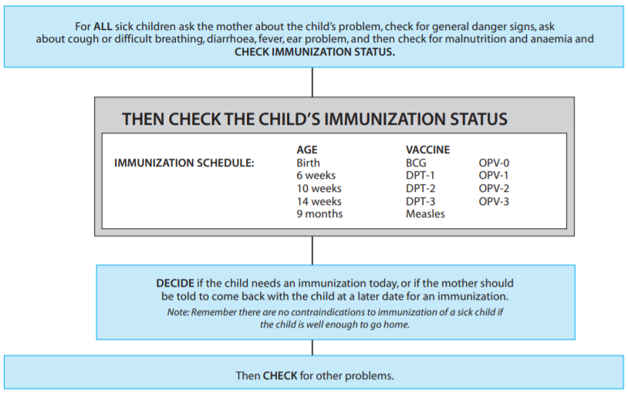

How to check the Immunization Status

- If an infant has not received any immunization, then give
–BCG
–DPT 1 , OPV 1
–Hepatitis B 1

THE SICK YOUNG INFANT AGE 1 WEEK UP TO 2 MONTHS: ASSESS AND CLASSIFY

Summary of assess and classify

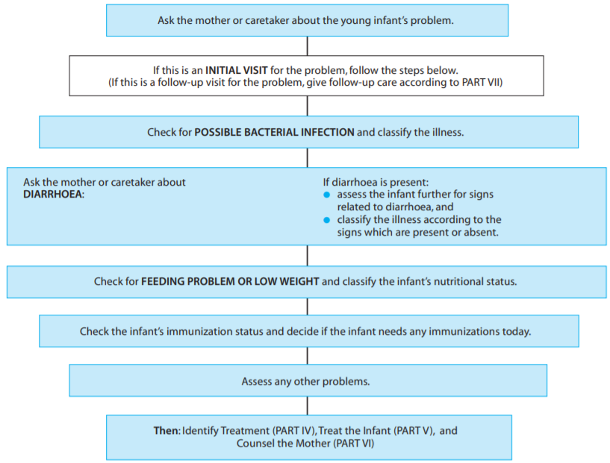

How to check a young infant for possible bacterial infection

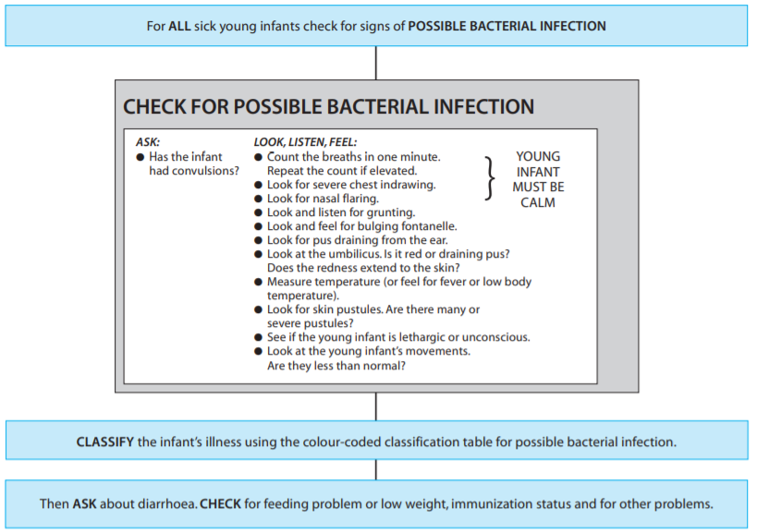

CLASSIFICATION TABLE FOR POSSIBLE BACTERIAL INFECTION

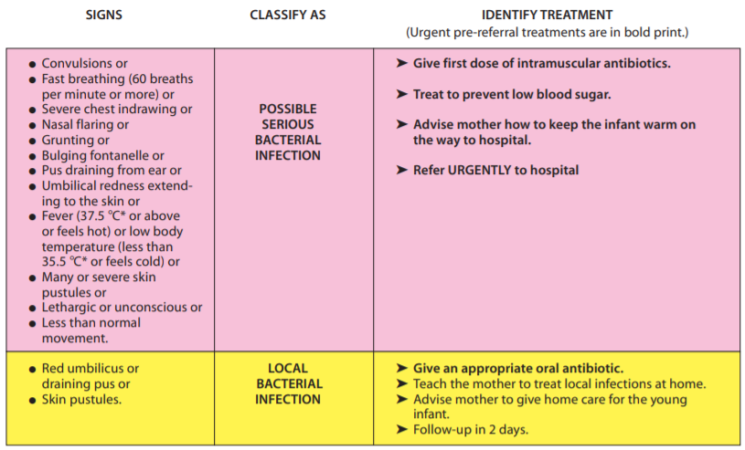

How to assess and classify a young infant for diarrhea?
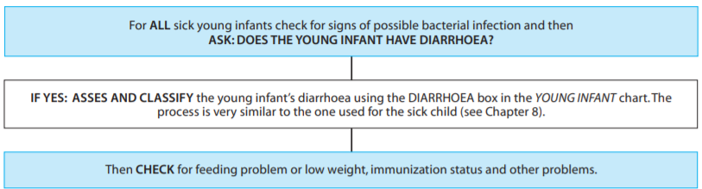

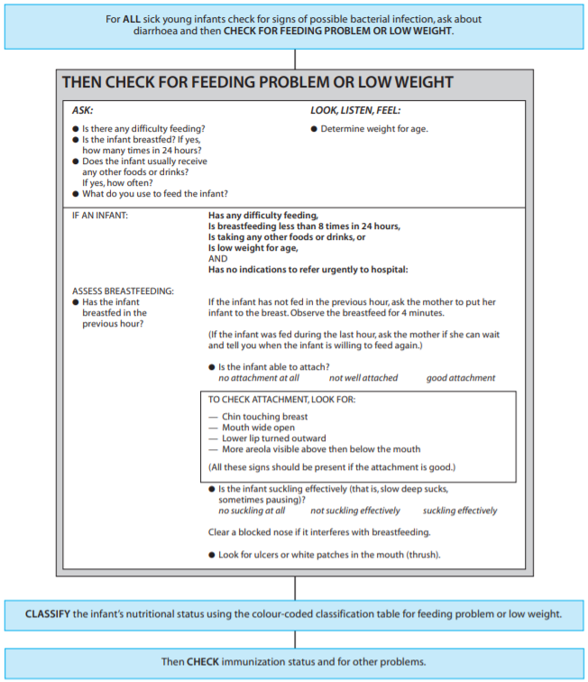

CLASSIFICATION TABLE FOR FEEDING PROBLEM OR LOW WEIGHT
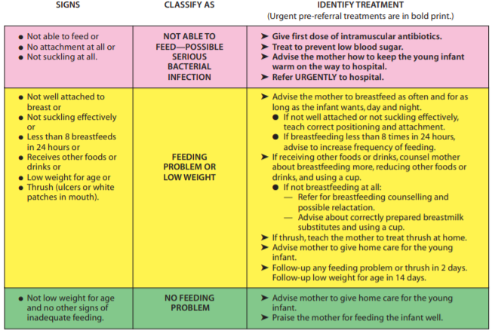

COMMUNICATE AND COUNSEL

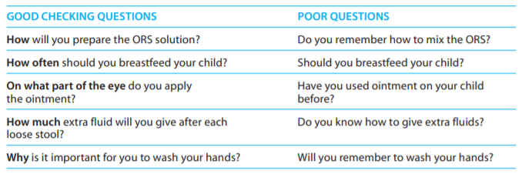

GIVE FOLLOW-UP CARE

Follow-up care for the sick young infant

- When to return immediately immediately.
–Signs of any of the following:
–Breastfeeding feeding or drinking poorly
–Becomes sicker
–Develops a fever
–Fast breathing
–Difficult breathing
–Blood in the stool
- Follow-up in 2 days – on antibiotics for local bacterial infection or dysentery
- Follow-up in 2 days - with a feeding problem or oral thrush
- Follow-up in 14 days – with low weight for age

Follow-up visit table in the counsel the mother chart

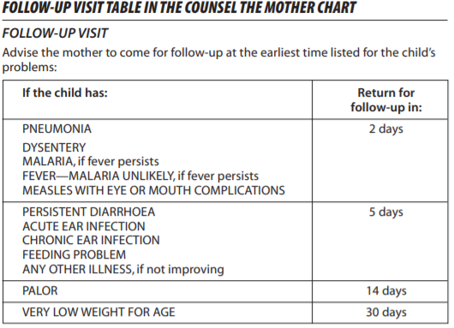

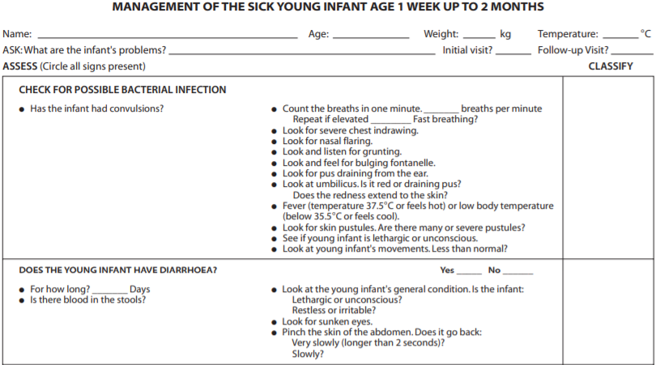

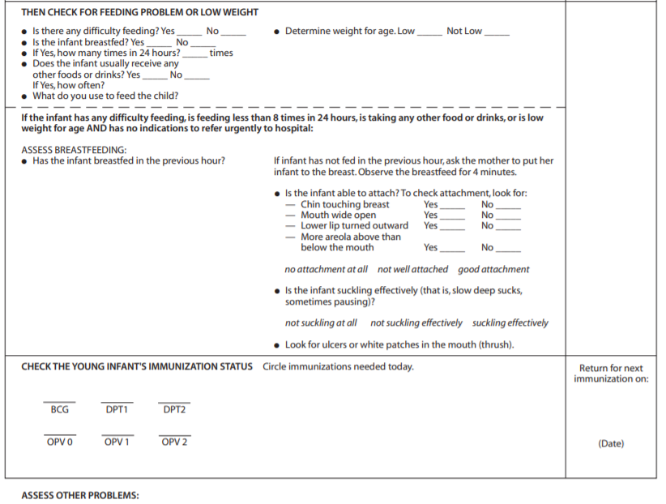

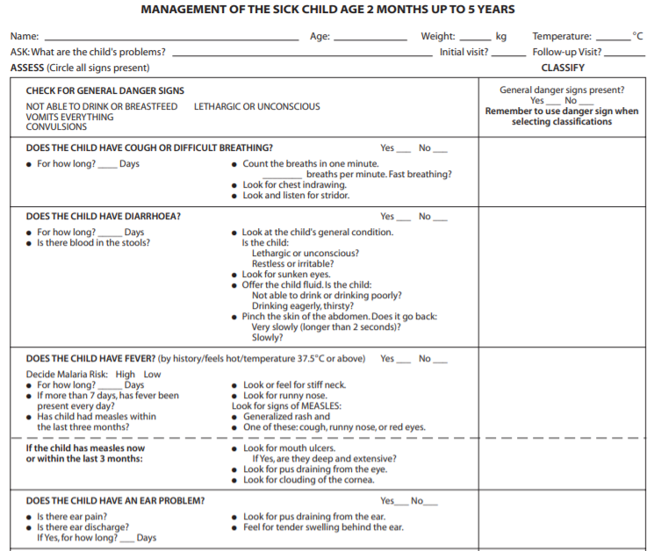

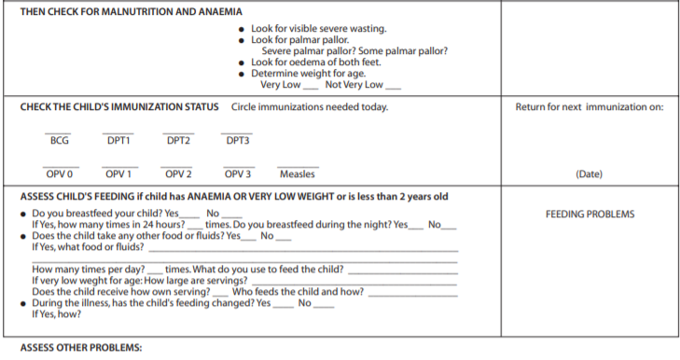

Submit: Word File
Points: 50 points

Question:

Get a case in your RLE duty with a sick child and use the IMCI chart booklet in diagnosing the child. Use the each steps in diagnosing the sick child.

Famorca, Z., Nies, M., & McEwen, M., (2013). Nursing Care of the Community. ELSEVIER MOSBY.

