BACHELOR OF SCIENCE IN NURSING:
COMMUNITY HEALTH NURSING
COURSE MODULE | COURSE TOPIC | WEEK
I | I | I
OVERVIEW OF PUBLIC HEALTH NURSING IN THE PHILIPPINES
- Read course and unit Rea
- Read study guide prior to class attendance
- Read course unit and objectives
- Read required learning resources; refer to unit
terminologies for jargons
- Proactively participate in classroom/online discussions
- Participate in weekly discussion board (Canvas)
- Answer and submit course unit tasks
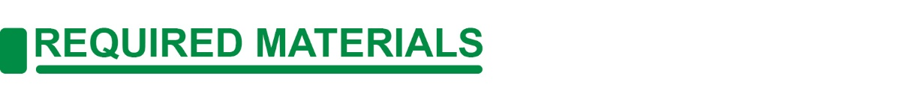
- Module, Reference Books, Laptop, Internet, Headset
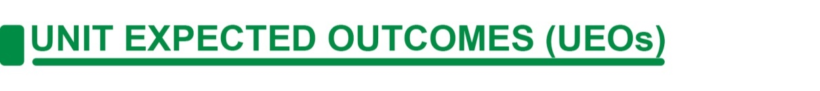
Cognitive
- Discuss appropriate community health nursing concepts and actions holistically and comprehensively.
- Compare the task between WHO and DOH.
- Evaluate the different values and statistical data provided by DOH and WHO.
Affective
- Model professional behavior as community health nurse
- Maintain a harmonious and collegial relationship among members of the health team for effective, efficient and safe client care.
- Listen to your professor as they teach the lesson.
- Value the importance of these organizations

Psychomotor
- Manage resources efficiently and effectively.

A. GLOBAL AND NATIONAL HEALTH SITUATIONS

GLOBAL
WHO | WORLD HEALTH ORGANIZATION
We are building a better, healthier future for people all over the world. Together we strive to combat diseases – communicable diseases like influenza and HIV, and noncommunicable diseases like cancer and heart disease.
Who We Are? | Established 7 April 1948. – a date we now celebrate every year as World Health Day. Headquarters in Geneva, Switzerland
What We Do? | Our primary role is to direct and coordinate international health within the United Nations system.  Our main areas of work are health systems; health through the life-course; noncommunicable and communicable diseases; preparedness, surveillance and response; and corporate services.
Where We Work? | We support countries as they coordinate the efforts of governments and partners – including bi- and multilaterals, funds and foundations, civil society organizations and the private sector
How We Are Governed? | The World Health Assembly is attended by delegations from all Member States, and determines the policies of the Organization.
Who We Work With? | Our core function is to direct and coordinate international health work through collaboration.  WHO partners with countries, the United Nations system, international organizations, civil society, foundations, academia, and research institutions.

GLOBAL HEALTH SITUATION

Impact of COVID-19 on population health

COVID-19 poses major challenges to population health and well-being globally and hinders progress in meeting the SDGs and WHO’s Triple Billion targets.

The WHO Triple Billion targets are a shared vision among WHO and Member States, which help countries to accelerate the delivery of the SDGs. By 2023 they aim to achieve: one billion more people enjoying better health and well-being, one billion more people benefiting from universal health coverage (covered by health services without experiencing financial hardship) and one billion more people better protected from health emergencies.

As of 1 May 2021, over 153 million confirmed COVID-19 cases and 3.2 million related deaths have been reported to WHO. The Region of the Americas and the European Region have been the most affected, together comprising over three quarters of cases reported globally, with respective case rates per 100 000 population of 6114 and 5562 and almost half (48%) of all reported COVID-19-associated deaths occurring in the Region of the Americas, and one third (34%) in the European Region.

Of the 23.1 million cases reported in the South-East Asia Region to date, over 86% are attributed to India. Despite the extensive spread of the virus, COVID-19 cases to date appear to be concentrated predominantly in high-income countries (HICs). The 20 most impacted HICs account for almost half (45%) of the world’s cumulative COVID-19 cases, yet they represent only one eighth (12.4%) of the global population.

COVID-19 has surfaced long-standing inequalities across income groups, disrupted access to essential medicines and health services, stretched the capacity of the global health workforce and revealed significant gaps in country health information systems.
While high-resource settings have faced challenges related to overload in the capacity of health services, the pandemic poses critical challenges to weak health systems in low-resource settings and is jeopardising hard-won health and development gains made in recent decades.

Data from 35 high-income countries shows that preventive behaviours decrease as household overcrowding (a measure of socioeconomic status) increases.
Overall, 79% (median value of 35 countries) of people living in uncrowded households reported trying to physically distance themselves from others compared to 65% in extremely overcrowded households. Regular daily handwashing practices (washing hands with soap and water or using hand sanitizers) were also more common among people who lived in uncrowded households (93%) compared to those living in extremely overcrowded households (82%). In terms of mask-wearing in public, 87% of people living in uncrowded households wore a mask all or most of the time when in public in the last seven days compared to 74% of people living in extremely overcrowded conditions.

Life expectancy and healthy life expectancy
The global population continues to live longer and live more years in good health. Between 2000 and 2019, global life expectancy (LE) at birth increased from 66.8 years in 2000 to 73.3 years in 2019, and healthy life expectancy (HALE) increased from 58.3 years to 63.7 years. Despite sharing similar increasing trends, LE and HALE among females were consistently higher than males.

LE and HALE also rise with national income levels, however the fastest improvements were observed in low-income countries (LICs), gaining over 11 years in LE and nearly 10 years in HALE in 2000-2019, predominantly reflecting the remarkable progress made in reducing mortality among children under 5 years of age in the past 20 years.

Burden of disease
Thanks to sustained global efforts, significant progress continues to take place, particularly in reducing the number of deaths caused by communicable, maternal, perinatal and nutritional conditions (communicable diseases hereafter). Progress in preventing and treating these diseases (especially those that tend to kill children under 5 years of age) has seen them decline significantly relative to noncommunicable diseases and injuries. Consequently, the global share of NCD deaths among all deaths increased from 60.8% in 2000 to 73.6% in 2019.
It is not just deaths that are falling from communicable diseases – Disability Adjusted Life Years (DALYs) and Years Lived with Disability (YLD) are all decreasing. Again, not just the extension of life, but the extension of healthy life. This is a global success worth celebrating and sustaining.
A huge factor in this story is the great advances in reducing some of the world’s leading infectious diseases. HIV/AIDS and tuberculosis have both dropped out of the top 10 global causes of death in 2019. At the global level, this means seven of the top 10 causes of death in 2019 were non-communicable diseases. This is an increase from four of the top 10 causes in 2000.
Tuberculosis (TB) remains the world’s leading cause of death from a single infectious agent. Globally, an estimated 10 million (range, 8.9–11 million) people fell ill with TB in 2019, a number that has been declining very slowly in recent years but not fast enough to reach the 2020 milestone of a 20% reduction between 2015 and 2020.
New HIV infections have been reduced by 40% since the peak in 1998. In 2019, around 1.7 million people were newly infected with HIV, more than a million fewer than in 1998. However, this is far from the 2020 global milestone of below 500 000 new infections.
The malaria mortality rate has been more than halved: from 25 deaths per 100 000 population at risk in 2000 to just 10 per 100 000 population at risk in 2019. The total number of malaria deaths worldwide fell from 736 000 in 2000 to 409 000 in 2019.

Universal health coverage

Achieving Universal health Coverage (UHC) is one of the targets the nations of the world set when adopting the SDGs in 2015 and when reaffirming this commitment at the United Nations General Assembly High Level Meeting on UHC in 2019. It means that all individuals and communities receive the health services they need without suffering financial hardship.

Although improvements in coverage of essential health services have been recorded in all income groups and across different types of services – with the UHC service coverage index (SCI) increasing from a global average of 45 (of 100) in 2000 to 66 in 2017 – many inequalities persist. Globally and for many countries, the pace of progress has slowed since 2010, and the poorest countries and those affected by conflict generally lag furthest behind.

Overall, financial protection prior to COVID-19 has been deteriorating. The proportion of the population with out-of-pocket spending exceeding 10% of their household budget rose from 9% to 13% and those exceeding 25% rose from 1.7% to 2.9%, over the period 2000-2015. Continued progress requires considerable strengthening of health systems, particularly in lower income settings, along with a recognition of the crucial role of healthcare workers in public health capacity with adequate protection for their safety and wellbeing.

Health Workforce

The global health workforce has responded heroically since the pandemic began. And fittingly, 2021 has been designated International Year of Health and Care Workers in appreciation of their unwavering dedication in the fight against COVID-19. Yet the world needs millions more of them if it is to achieve universal health coverage by 2030.
There are dramatic disparities in the number of people for each health worker across different WHO regions. This reveals just how varied the distribution is throughout the world and highlights the unacceptable scarcity of health workers in some regions.
Regionally, health workers who deliver essential services are at their lowest density in the places where the highest burden of disease was measured. Even when national densities are sizable, inequalities persist between rural, remote and hard-to-reach areas compared to capital cities and urban centers. According to the latest available data from 2014-2019, density of health workers is the lowest in the WHO African Region, with just three doctors per 10 000 population and 10 nursing/midwifery personnel per 10 000 population.
According to the data available for 2014–2020, 83% of global births were assisted by skilled birth attendants, including medical doctors, nurses and midwives. This is an increase of about 30% compared to data from 2000–2006. These frontline health professionals are the people who respond to both emergencies and everyday needs. Investments in better infrastructure for health facilities, continuous education and capacity-building and better working conditions for health and care workers – all relevant to universal health coverage – will be crucial.

NATIONAL
DOH| DEPARTMENT OF HEALTH

The Department of Health (DOH) holds the over-all technical authority on health as it is a national health policy-maker and regulatory institution.

Mission | To lead the country in the development of a productive, resilient, equitable and people-centered health system
Vision | Filipinos are among the healthiest people in Southeast Asia by 2022, and Asia by 2040
Roles in the Health Sector | (1) leadership in health; (2) enabler and capacity builder; and (3) administrator of specific services
Mandate | To develop national plans, technical standards, and guidelines on health
National Health Situation

Health System

Health service delivery

The Philippines has a mixed public-private healthcare system that operates within a fragmented environment. The private sector caters to only about 30 percent of the population but is far larger than the public system in terms of financial resources and staff (Oxford Business Group, 2018). It provides healthcare that is generally paid through user fees at point of service. About 65 percent of the 1,224 hospitals in the country in 2016 were private (DOH-HFSRB, 2016).

Health financing

The National Health Insurance Act of 1995 created the Philippine Health Insurance Corporation (PhilHealth) to provide health insurance coverage for all Filipinos but enrolment was not made compulsory. In 2013, it was amended, expanding the contribution based national health insurance program (NHIP) beyond formal employment to include the underprivileged, sick, elderly, persons with disabilities (PWDs) and women and children. It strengthened the roles of the LGUs and health providers in NHIP enrolment.

Health governance and regulation

The enactment of LGC in 1991 led to dual governance in health, with the DOH governing at the national level and the LGUs at the subnational level. The DOH serves as the over-all steward and technical authority on health being the national health policy-maker and regulatory institution. It is mandated to develop national plans, technical standards, and guidelines on health. It is also in charge of licensing hospitals, laboratories and other health facilities through the Health Facilities and Service Regulatory Bureau (HFSRB), and health products through the Food and Drug Administration (FDA). PhilHealth automatically accredits DOH licensed facilities. Meanwhile, the Insurance Commission (IC) regulates and supervises the operations of private insurance companies, and since 2015, of health maintenance organizations as well, except PhilHealth. The DOH also coordinates government, private sector and development partner assistance on health and leverages funds for improved health performance.

Health Trends

Based on PSA 2000 Census-based projections, the average life expectancy improved from 67.1 years in 2000-2005 to 71.6 years in 2015-2020. Modest gains were also achieved in infant and under-five mortalities as shown by mortality data from five demographic surveys conducted from 1993 to 2013. Infant mortality rate decreased from 34 per 1,000 live births to 23 per 1,000 live births and under-five mortality rate went down from 54 per 1,000 live births to 31 per 1,000 live births. Th e rates of decline, however, slowed down over the period. Meanwhile, the MMR has minimal progress from 126 per 100,000 live births in 2012 to 114 per 100,000 live births in 2015.

In terms of nutrition, the 8th National Nutrition Survey showed that stunting remained almost unchanged from 33.1 percent in 2005 to 33.4 percent in 2015. Stunting was observed to be high among those residing in rural areas (38.1 percent) and those belonging to the poorest quintiles (49.7 percent)

According to the DOH 2016 Annual Report, TB case detection rate and treatment success rate both exceeded the national targets of 93.6 and 90 percent, respectively. Nonetheless, the Philippines remained to be one of the 30 high TB burden countries in the world, with an estimated incidence of 554 per 100,000 population in 2016 (WHO, 2017). Th e National TB Prevalence Survey (NTPS) 2016 estimated prevalence of smear-positive TB at 434 per 100,000 population, and of bacteriologically confirmed TB at 1,159 per 100,000 population.

Mortality and Morbidity
The leading causes of mortality in the Philippines in 2016 consisted of non-communicable diseases (NCDs) like ischemic heart disease, neoplasms or cancer, cerebrovascular diseases or stroke, hypertensive diseases, diabetes and other heart diseases, and communicable diseases like pneumonia, respiratory tuberculosis and chronic lower respiratory infections. Several NCDs share common lifestyle-related risk factors: cigarette smoking, hypertension, hyperglycemia, dyslipidemia, obesity, physical inactivity and poor nutrition (Asena et al., 2015). Ischemic heart disease remained to be the top leading cause of death in the country, followed by cancer and pneumonia. While assault did not appear on this table, it was included in the top 10 leading causes of death for males in 2016. In the previous years, accident figured prominently in the list, ranking as the fifth highest among the leading causes of mortality from 2012-2014 (DOH, 2016a).

Meanwhile, morbidity in 2016 was caused mainly by acute respiratory infection, followed by hypertension, acute lower respiratory tract infection (ALRTI) and pneumonia. These were the same top three causes of morbidity in 2012, except that the second and third top diseases interchanged ranks. Leading causes of morbidity were all communicable diseases, except for hypertension.

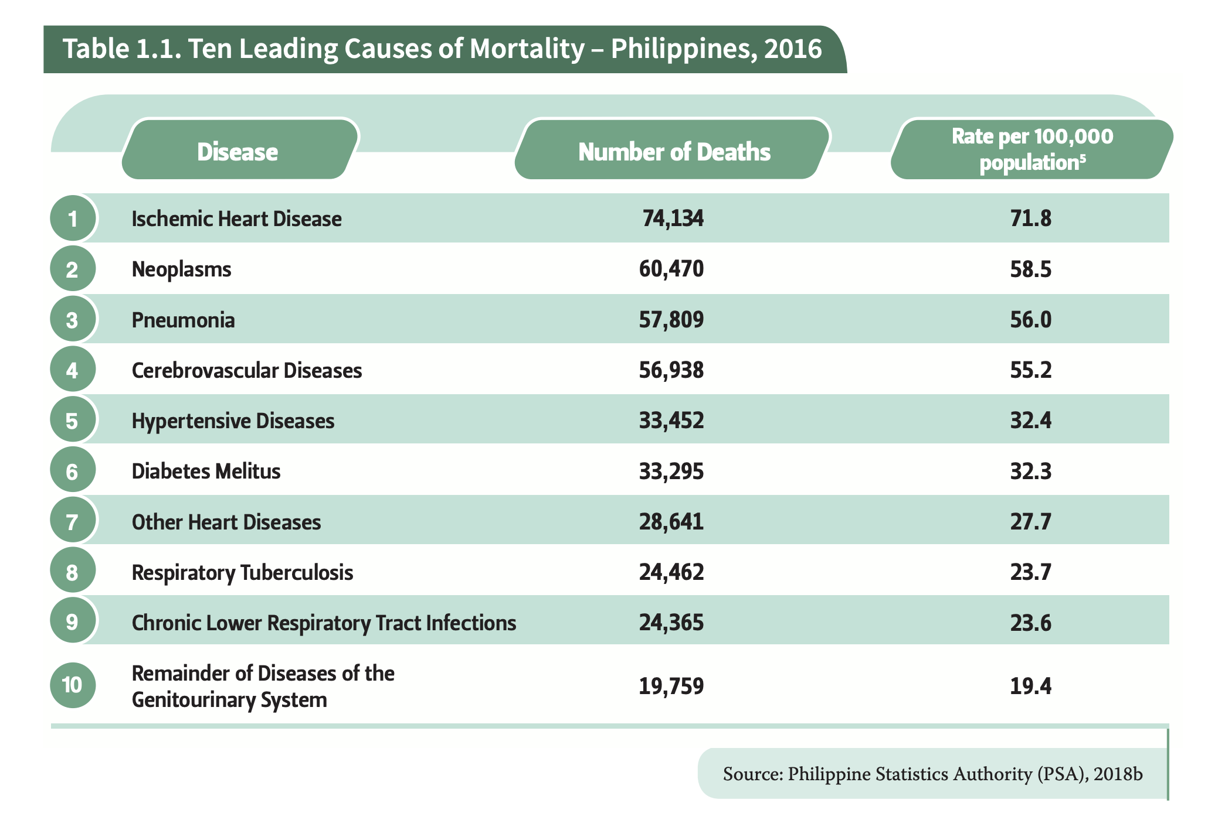
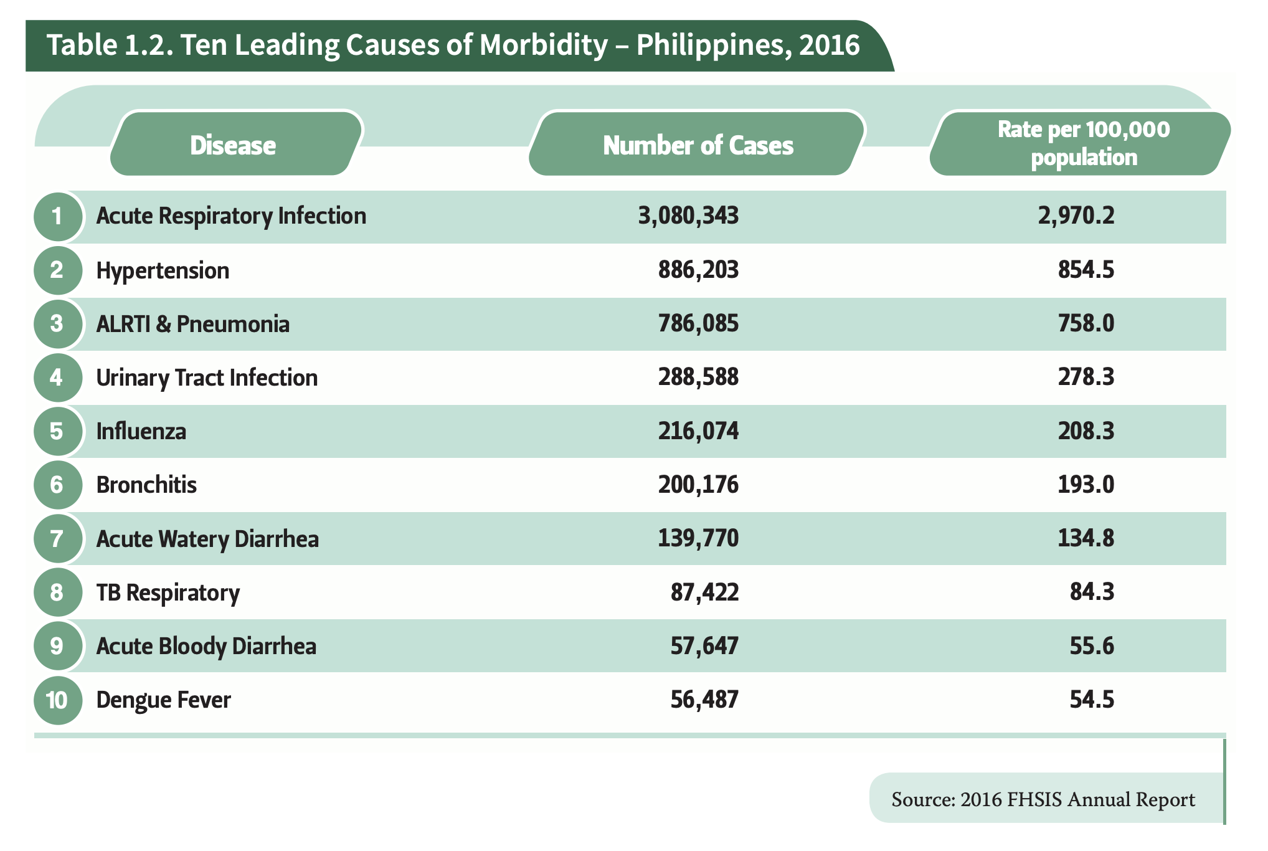
Despite living longer than in previous years, Filipinos now bear a triple burden of disease with the high prevalence of communicable diseases and NCDs. Filipinos are also susceptible to risks brought by the increasing impact of globalization and climate change, with the Philippines ranking third in the world in terms of exposure to disaster risks (Dayrit et al., 2018). Thousands have died from previous rapid onset disasters that struck the country, commonly owing to trauma, drowning or crush-related injuries. Moreover, flooding can increase transmission of certain diseases such as leptospirosis and dengue, while power cuts may disrupt water treatment and supply, exposing the population to the risk of water-borne diseases (WHO, 2018b).

B. DEFINITION AND FOCUS

1. PUBLIC HEALTH
Definition of public health according to:
C. E. Winslow- “Public health is the science and art of (1) preventing disease, (2) prolonging life, and (3) promoting health and efficiency through organized community effort for:
- sanitation of the environment,
- control communicable infections,
- education of the individual in personal hygiene,
- organization of medical and nursing services for the early diagnosis and preventive treatment of disease, and
- development of the social machinery to ensure everyone a standard of living adequate for the maintenance of health, so organizing these benefits as to enable every citizen to realize his birthright of health and longevity.” (Hanlon)

2. COMMUNITY HEALTH
Community Health is a term used to describe the state of health and how easy or difficult it is to be healthy where people live, learn, work and play. The health of a community, including ease of access to medical care and community resources available for exercise and encouraging healthy habits, is an important part of emergency planning that can have a positive impact on a community before, during, and after a public health emergency. (Centers for Disease Control and Prevention)

3. PUBLIC HEALTH NURSING
- A component or subset of CHN
- The synthesis of public health and nursing practice
- Defined as the field of professional practice in nursing and in public health in which technical nursing, interpersonal, analytical, and organizational skills are applied to problems of health as they affect the community. These skills are applied in concert with those of other persons engaged in health care, through comprehensive nursing care of families and other groups and through measures for evaluation or control of threats to health, for health education of the public and for the mobilization of the public for health action. (Freeman, 1963)
- The practice of promoting and protecting the health of populations using knowledge from nursing, social and public health sciences (ANA; American Public Health Association, 1996)
- Population-focused, with the goals of the promoting health and preventing disease and disability for all people through the creation of conditions in which people can be healthy.(ANA, 2007)

4. COMMUNITY HEALTH NURSING
Definition of Community Health Nursing according to ANA, 1980
- synthesis of nursing practice and public health practice applied to promoting and preserving health of the populations
- broader and more general specialty area that encompasses subspecialties that include public health nursing, school nursing, occupational health nursing, and other developing fields of practice, such as home health, hospice care, and independent nurse practice”

5. STANDARDS OF PUBLIC HEALTH NURSING IN THE PHILIPPINES
- Safe and Quality Nursing Care - knowledge of health/illness status of the client, sound decision making; safety, comfort, privacy, administration of meds and health therapeutics and nursing process.
- Management of resources and environment - organization of workload; use of financial resources for client care; mechanism to ensure proper functioning of equipment and maintenance of a safe environment
- Health Education - assessment of client’s learning needs; development of health education plan and learning materials and implementation and evaluation of health education plan
- Legal Responsibility - adherence to the nursing laws as well as to national, local and organizational policies including documentation of care given to clients.
- Ethicomoral Responsibility - respect for the rights of the client; responsibility and accountability for own decisions and actions; and adherence to the international and national codes of ethics for nurses
- Personal and Professional Development - identification of own learning needs, pursuit of continuing education; involvement in professional image; positive attitude towards change and criticism
- Quality Improvement - data gathering for quality improvement; participation in nursing rounds; identification and reporting of solutions to identifies problems related to client care.
- Research - research-based formulation of solutions to problems in client care and dissemination and application of research findings
- Records Management - accurate and updated documentation of client care while observing legal imperatives and record keeping
- Communication - uses therapeutic communication techniques, identifies verbal and nonverbal cues, responds to client needs, while using formal and informal channels of communication and appropriate information technology
- Collaboration and Teamwork - establishment of collaborative relationship with colleagues and other members of health team

6. EVOLUTION OF PUBLIC HEALTH NURSING IN THE PHILIPPINES
1577 - Franciscan FriarJuan Clemente opened medical dispensary in Intramuros for the indigent

1690 – Dominican Father Juan de Pergero worked toward installing a water system in San Juan del Monte and Manila

1805 – smallpox vaccination was introduced by Francisco de Balmis , the personal physician of King Charles IV of Spain

1876 – first medicos titulares were appointed by the Spanish government

1888 - 2-year courses consisting of fundamental medical and dental subjects was first offered in the University of Santo Tomas. Graduated were known as “cirujanosministrantes” and serve as male nurses and sanitation inspectors

1901 – United States Philippines Commission, through Act 157, created the Board of Health of the Philippine Islands with a Commissioner of the Public Health ,as its chief executive officer (now the Department of Health)

Fajardo Act of 1912 – created sanitary divisions made up of one to four municipalities. Each sanitary division had a president who had to be a physician

1915 - the Philippine General hospital began to extend public health nursing services in the homes of patients by organizing a unit called Social and Home Care services
Asociacion Feminista Filipina (1905) – Lagota de Leche was the first center dedicated to the service of the mothers and babies

1947 – the Department of Health was reorganized into bureaus: quarantine, hospitals that took charge of the municipal and charity clinics and health with the sanitary divisions under it.

1954 – Congress passed RA 1082 or the Rural Health Act that provided the creation of RHU in every municipality

RA 1891 – enacted in 1957 amend certain provisions in the Rural Health Act•Created 8 categories of rural health units corresponding to the population size of the municipalities

RA 7160 (Local Government Code) – enacted in 1991, amended that devolution of basic health services including health services, to local government units and the establishment of a local health board in every province and city of municipality

Millennium Development Goals – adopted during the world summit in September 2000

FOURmula One (F1) for health, 2005 and Universal Health Care in 2010 – agenda launched in 1999

Universal Health Care – aims to achieve the health system goals of better health outcomes, sustained health financing, and responsive health system that will provide equitable access to health care

7. ROLES AND RESPONSIBILITIES OF A COMMUNITY HEALTH NURSE
1. The main focus of community health nurse is health promotion.

Programmer/Planner
- Identifies the needs and concerns of individuals, groups, families, and the community
- Formulates health plans, especially in the absence of a community physician
- Interprets and implements nursing plans and programs
- Assists other health team members in implementing health programs in the setting
Health Educator/Trainer/ Counsellor
- Acts as resource speaker on health and health-related services
- Advocates health programs in the community through dissemination of IEC or Information Education and Communication materials
- Conducts advocacy educations concerning premarital, breastfeeding, and immunization counsellings
- Organizes orientation/ training of concerned groups like pregnant mothers
- Identifies and interprets training needs of health team members and formulate appropriate training program for them
- Conducts and facilitates necessary training or educational orientation to other health team members in the community

2. The recipient of care of community public health nursing practice is extended not only to the individual but also to benefit the whole family and community.

Community Organizer
- Promotes self- reliance of community and emphasizes their involvement and participation in planning, organizing, implementing and evaluating of health services
- Initiates and implements community development activities

Coordinator of services
- Coordinates health services with concerned individuals and families through the community health team members, government organizations and non- government organizations
- Coordinates nursing plans and programs with other health programs

3. Community health nurses are generalists in terms of their practice through life’s continuum.

Provider of Nursing Care
- Renders direct care to various clients with different needs, may it be at home, in school, clinics or work settings
- Involves the family in the care of the sick or dependent individual, i.e., sick child

4. Continuity of care with the client, family or and the community extends for a longer time involving individuals of all ages and health needs.

Health Monitor
- Monitors and detects the presence of health concerns in the community through contacts or home visits.
- Utilizes various effective data gathering techniques in keeping an eye on the health status of all recipients of care.
- Records and reports health status and presence of health problems in the community

5. The nature of nursing practice in the community needs the knowledge of biological and social sciences, ecology, clinical nursing, and community organizing, for it to be effective.

Researcher
- Follows a systematic process of monitoring the health status of the community through the conduct of surveys and home visits
- Conducts researches concerning the health of the community
- Coordinates with government and non- government organizations in the conduct and implementation of studies

Statistician
- Records data systematically and ensures its validity through accurate and complete data gathering
- Reports prepared reports to concerned organizations i.e. government organization for immediate necessary plans or programs
- Consolidates and reviews reports efficiently.
- Analyzes and interprets consolidated data for monitoring the development in the health matters of the whole community

6. This field of nursing practice utilizes a dynamic process (assessment, planning, implementation, and evaluation) in the provision of continuous care until termination is implicit.

Change Agent
- Promotes and motivates change in the community in their health practices and lifestyle behaviors for them to promote and maintain good health, be knowledgeable and has the initiative in accessing health services
- Inculcates self- reliance to brought about development and improvement in the community

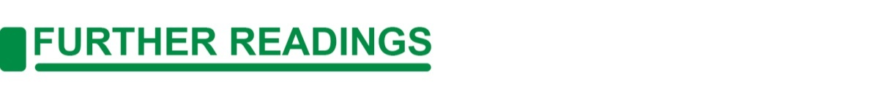
Famorca, Z., Nies, M., & McEwen, M., (2013). Nursing Care of the Community. ELSEVIER MOSBY.
W.H.O. (2020). 50 Facts: Global Health Situation and Trends 1955-2025. 27 June 2020. https://www.who.int/whr/1998/media_centre/50facts/en/

W.H.O. (2020). About WHO. 27 June 2020. https://www.who.int/about

D.O.H. (2020). DOH Profile. 27 June 2020. http://www.doh.gov.ph/profile

OCHA. (2019). Philippine Health Situation Snapshot. 27 June 2020. https://reliefweb.int/sites/reliefweb.int/files/resources/191024_OCHA_PHL_humanitarian%20health_snapshot.pdf

D.O.H. (2016). DOH Statistics. 27 June 2020. https://www.doh.gov.ph/statistics

W.H.O. (June 26, 2020). Situation Report -158. 27 June 2020. https://www.who.int/docs/default-source/coronaviruse/situation-reports/20200626-covid-19-sitrep-158.pdf?sfvrsn=1d1aae8a_2

D.O.H. Healthy Pilipinas (2020). About COVID-19. 27 June 2020. https://covid19.healthypilipinas.ph/faqs/about-covid-19

